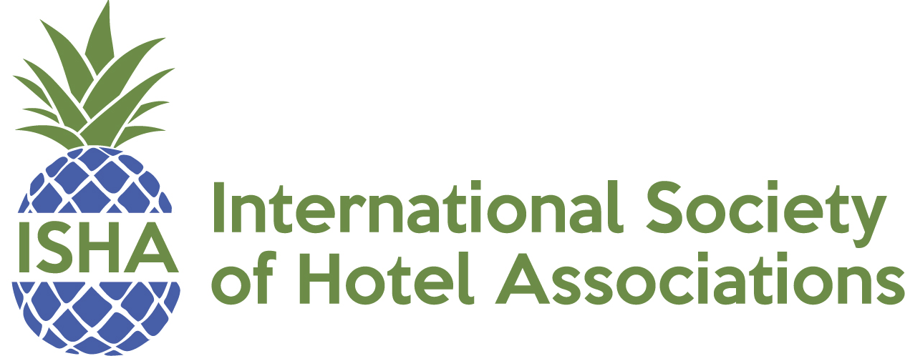

The Greenbrier
101 W. Main St.
White Sulphur Springs, WV 24986
1-855-453-4858

Monday, June 24, 2024
8:30 am – 11:00 am ISHA Board Meeting
Open to State Lodging Association CEO’s
Please RSP to Chris Pappas at cpappas@isha.biz

12:30 pm Registration

1:00 pm – 2:15 pm Mastering Full Funnel Marketing: Next Gen Strategies for Lodging Associations & Their Members
Speaker: Bill McGlade, epIQ Creative Group

In the competitive landscape of the hospitality industry, understanding and applying Full Funnel Marketing is crucial for lodging associations and their members aiming to maximize their market presence and guest satisfaction. This session, guided by industry expert Bill McGlade, will unpack the essentials of Full Funnel Marketing, emphasizing practical strategies that lodging associations can leverage and teach their members to attract, engage and convert guests at every stage of their journey. Incorporating AI as a tool, not the focal point, attendees will discover how to enhance each touchpoint, from initial awareness to loyal advocacy, effectively driving both member satisfaction and revenue.

Learner Outcomes:
- Gain a deep understanding of each state of the funnel and the key marketing strategies effective at the association and member levels
- Learn how lodging associations can support their members in implementing Full Funnel Marketing tactics that cater to potential guests from awareness to loyalty
- Explore how AI can be strategically used within Full Funnel Marketing to personalize member interactions, streamline operations and. enhance decision making process
2:15 pm – 2:45 pm AHLA Update
Speaker: Kevin Carey, Interim President & CEO, AHLA

Hear updates from AHLA and learn about upcoming priorities and programs

2:45 pm – 3:00 pm Break

3:00 pm – 4:30 pm Best Practices for Membership, Marketing & Events
Come to this session ready to brainstorm, learn, and share thoughts and ideas on challenges membership teams are faced with!

3:00 pm – 4:30 pm Best Practices for CEOs
Come to this session ready to brainstorm, learn, and share thoughts and ideas on challenges that face CEOs every day!

6:00 pm – 7:30 pm 2024 Summer Conference Opening Reception
Enjoy an evening of networking with your colleagues and peers at the 2024 Summer Conference Opening Reception.

Tuesday, June 25, 2024
7:30 am – 8:30 am Breakfast with ISHA & CSRA Partners

8:30 am – 9:00 am AHLEI Update
Speaker: TBD

Hear updates from AHLEI and learn about upcoming priorities and programs.

9:00 am – 9:30 am Storytelling for the Future
Speaker: TBD

9:30am – 10:30 am Forward Thinking Storytelling with Social Media
Speaker: Jesse Geremia

10:30 am – 10:45 am Break

10:45 am – 11:15 am Leveraging Large Events to grow membership
Speaker: TBD

11:15 am – 12:00 pm AI for Content & Visual Storytelling
Speaker: Dahlia ElGazzar

12:15 pm – 1:15 pm Lunch
Enjoy this networking lunch with your colleagues and peers

1:30 pm – 2:30 pm ELEVATE: Delivering Excellence in Member Service & Engagement
Speaker: Brad Anderson

Tailored specifically for leaders of hospitality associations dedicated to delivering exceptional customer service, this session focuses on equipping attendees and their teams with practical and easy to implement strategies for membership service and sales skills. Aimed at facilitating inquiries about new memberships or catering to existing members seeking service, education, or assistance on various membership-related topics, this training is designed to elevate service standards across the association.

Participants will delve into essential communication skills including impactful language, tone, and the right choice of words crucial in our daily interactions with our members. An emphasis and discussion on adjusting our sales and service approach by better understanding the various personality styles of members will be covered.

Walk away from this session with:
- Enhanced Communication Skills
- Adaptation to Member Personality Styles
- Practical Strategies for Membership Service and Sales
- Empowerment for Customer Engagement
- Refined Staff Communication Techniques
- Understanding Member Expectations
- Strategies for Membership Growth
- Increased Confidence in Handling Member Inquiries
- Cultivation of Stronger Customer Relationships

2:30 pm – 3:30 pm Strategic Resources for Membership Development
Panel: TBD

3:30 pm – 3:45 pm Break

3:34 pm – 4:30 pm Hands On AI Lab

4:45 pm – 6:00 pm Tour of Bunker

6:30 pm – 8:45 pm Dinner

Enjoy an evening networking with your peers and colleagues during dinner

Following dinner, enjoy a performance by legendary BMI Songwriter, John Ellison, who wrote the iconic song “Some Kind of Wonderful” and many others!

Sponsored by BMI.

Wednesday, June 26, 2024
7:30 am – 8:45 am AHA Breakfast
Open to ISHA members who participate in AHLA’s AHA

9:00 am – 9:30 am Leveraging CVBs for Marketing and to Grow Membership
Speaker: TBD

9:30 am – 10:15 am The ABCs of Polling and how can it be used for your advocacy efforts
Panel: TBD

10:15am – 11:30 am Interpreting Data
Speakers: TBD

11:45 am ISHA Summer Meeting Concludes

Save the Date!

ISHA Winter Conference
December 4 – 6, 2024
The Renaissance Hotel, Nashville, TN

